DriverPass System Design Document
Tyieshia Hasan-Watson
CS 255 Project Two
October 18, 2026
This design gives the development team a consistent model for customer registration, two-hour driving lessons, online training, and business oversight. A cloud-hosted web application will use one central data store so customers and staff work with the same records. The design combines process models for workflows with class models for stored information.

Design basis
The DriverPass Interview Transcript, Project One business requirements, and Module Six use case diagram form the basis of this design. The model preserves the roles, package restrictions, online-only changes, reporting, and audit requirements.
CASE tool: The revised UML model was imported into Lucidchart, visually verified, and exported for this document. The editable source contains all seven diagram views.
Editable model: https://lucid.app/lucidchart/a063bc40-1751-4ea4-9f02-ce56344cc82b/edit

Package rules
Package | Driving entitlement | Other training
One | 6 hours = 3 lessons | Driving only
Two | 8 hours = 4 lessons | In-person DMV rules lesson
Three | 12 hours = 6 lessons | In-person lesson, online class, and practice tests
Every driving lesson is two hours. Disabling a package stops new registrations; existing enrollments retain their purchased entitlement as a proposed policy. Adding or removing package modules is future scope. Downloaded reports support offline work, but offline updates and synchronization are outside this release.

UML Diagrams

UML Use Case Diagram
The use case model is divided into two views of the same DriverPass system to keep the relationships readable. Actors remain outside the boundary; ovals represent services and solid lines represent actor participation.
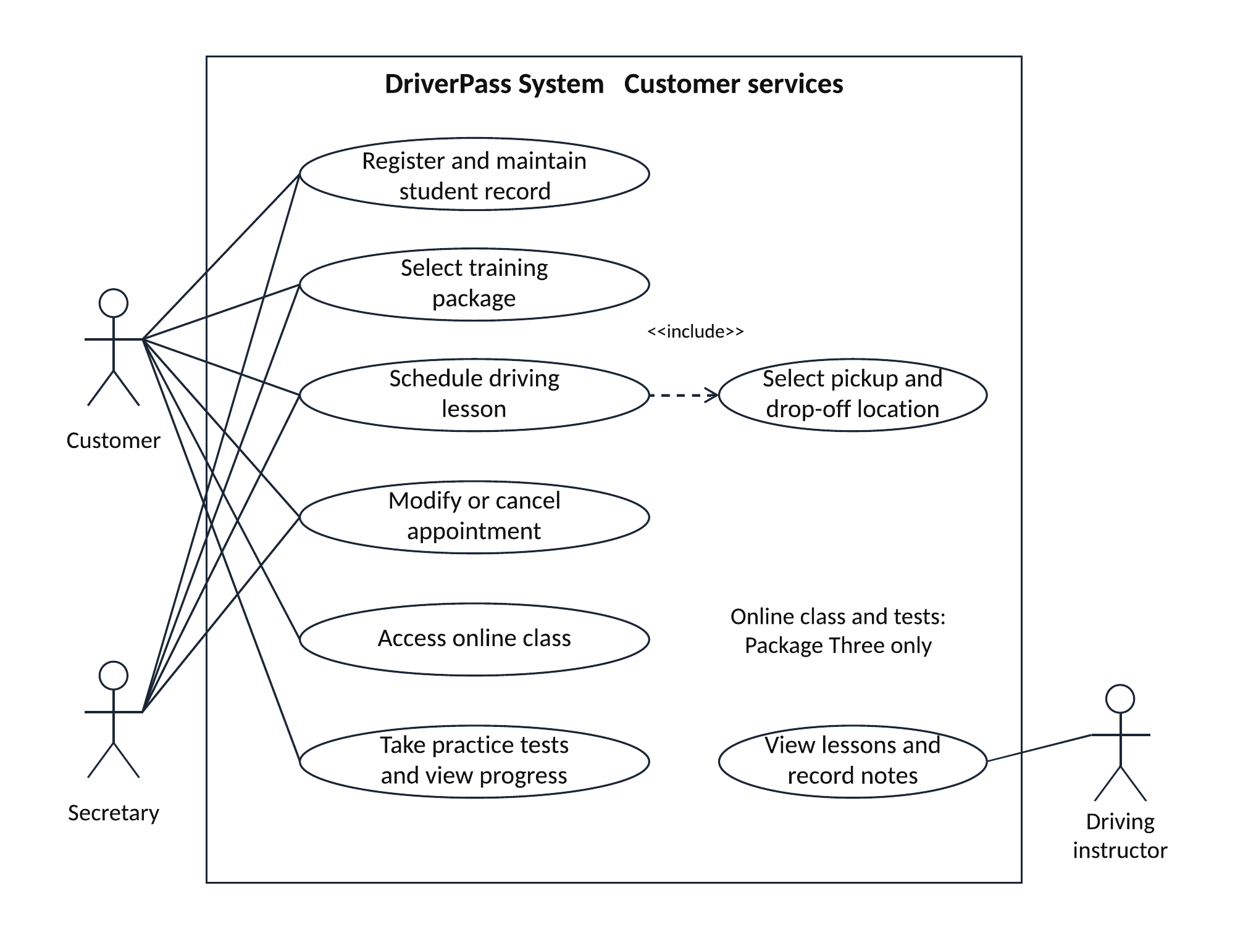
Figure 1. Customer services view. The dashed <<include>> arrow points from Schedule driving lesson to the required location selection.
Customers manage their own records. The secretary acts for a selected customer, while the audit trail records the secretary as the acting user. The system assigns an available driver and car pair as part of booking. Driver access to assigned lessons and note entry is the explicit Project One assumption. Customer progress includes test history and lesson notes.

UML Use Case Diagram continued
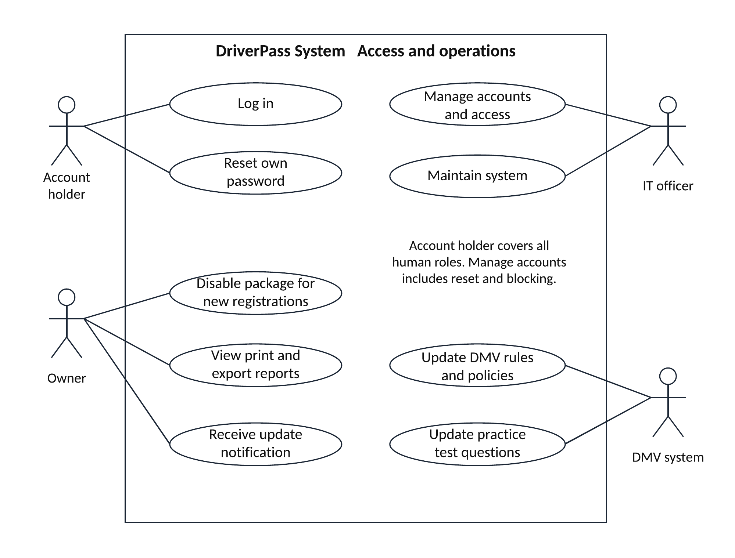
Figure 2. Access and operations view of the same use case model. Account holder represents each human role when using login or self-service recovery.
The DMV participates only in rules/policy updates and practice-question updates. Receiving either update produces a notification for DriverPass. The owner reviews reports and package availability. Ian manages accounts, including staff account creation, role changes, password reset, and blocking access. Authentication is a precondition for protected use cases, not a mandatory included step repeated inside every workflow.
Registration captures name, address, state, phone, and pickup/drop-off information. Payment entry uses a proposed hosted payment provider. A contact page and authorized staff contact tools support communication with customers. These supporting screens are described here rather than expanded into additional diagrams.

UML Activity Diagrams
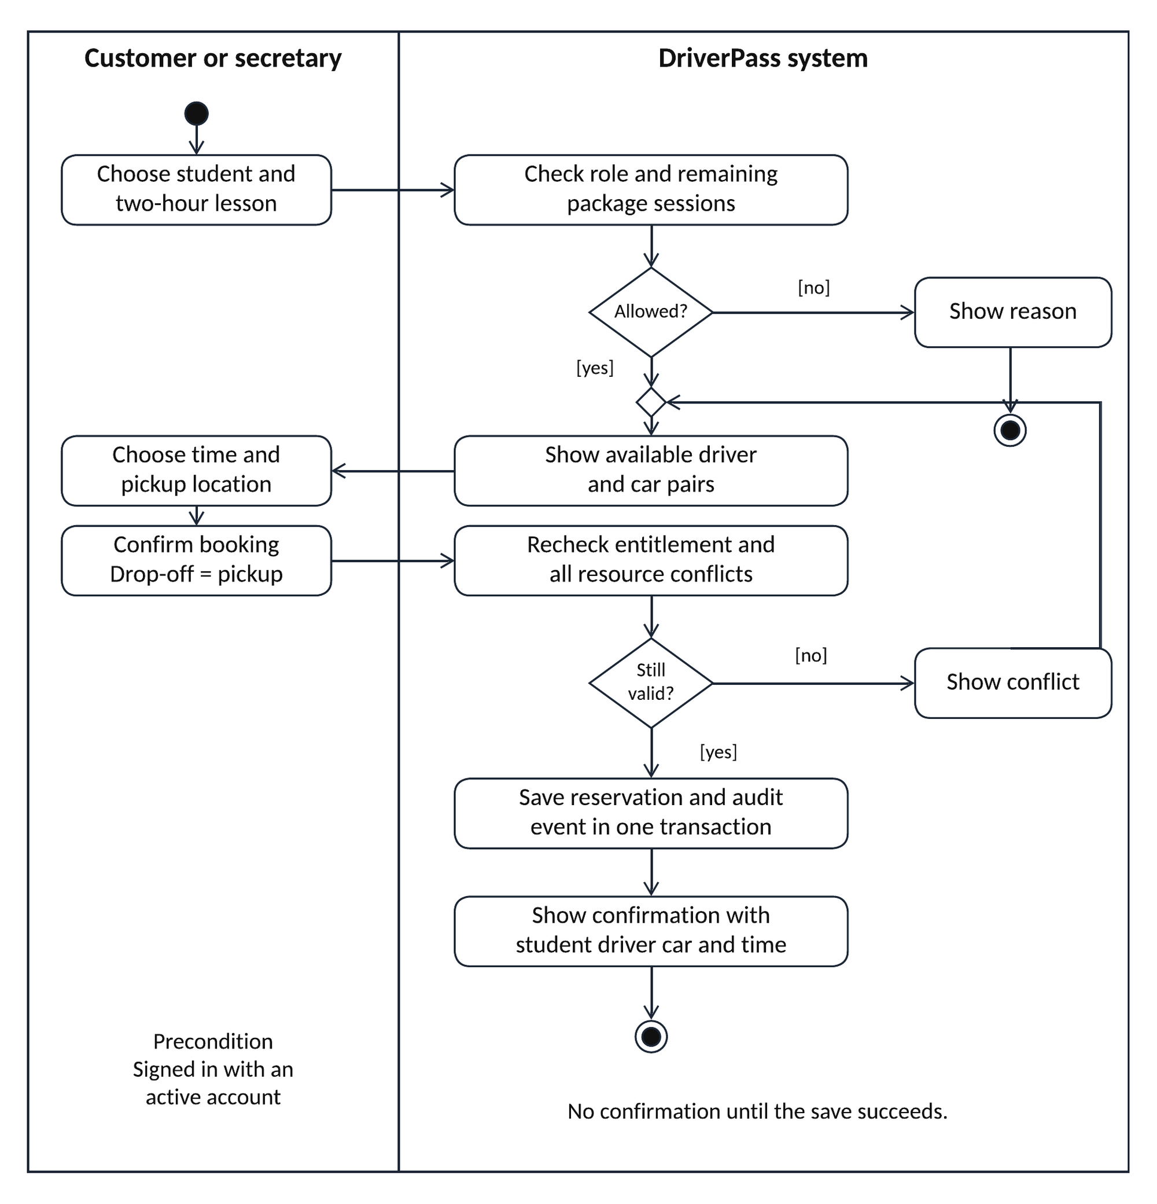
Figure 3. Schedule driving lesson. Filled circles start the activity; rounded rectangles are actions; diamonds carry guarded alternatives; bullseyes end the activity.
The signed-in actor must be allowed to book for the student. The final save checks entitlement and overlapping student, driver, and car reservations together. If saving fails, no booking is confirmed and no session allowance is consumed.

UML Activity Diagrams continued
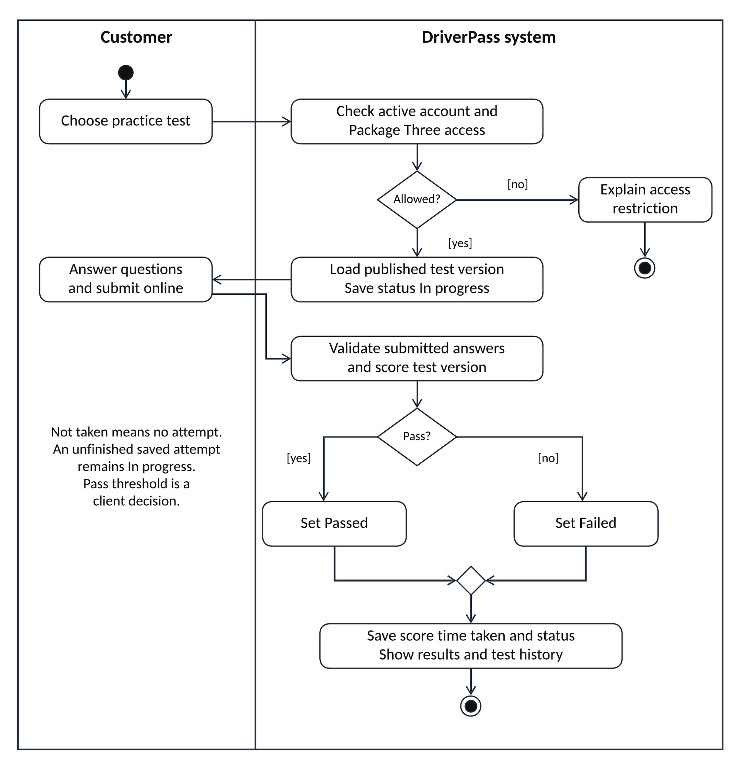
Figure 4. Take practice tests and view progress. The merge diamond joins the Passed and Failed branches. The result is stored with the test version and elapsed time.
Only Package Three grants online class and test access. The system displays Not taken when no attempt exists. An unfinished attempt remains In progress. A connection failure cannot create an offline update; the customer resumes from the last saved online state. The passing threshold and retry policy require client approval.

UML Sequence Diagram
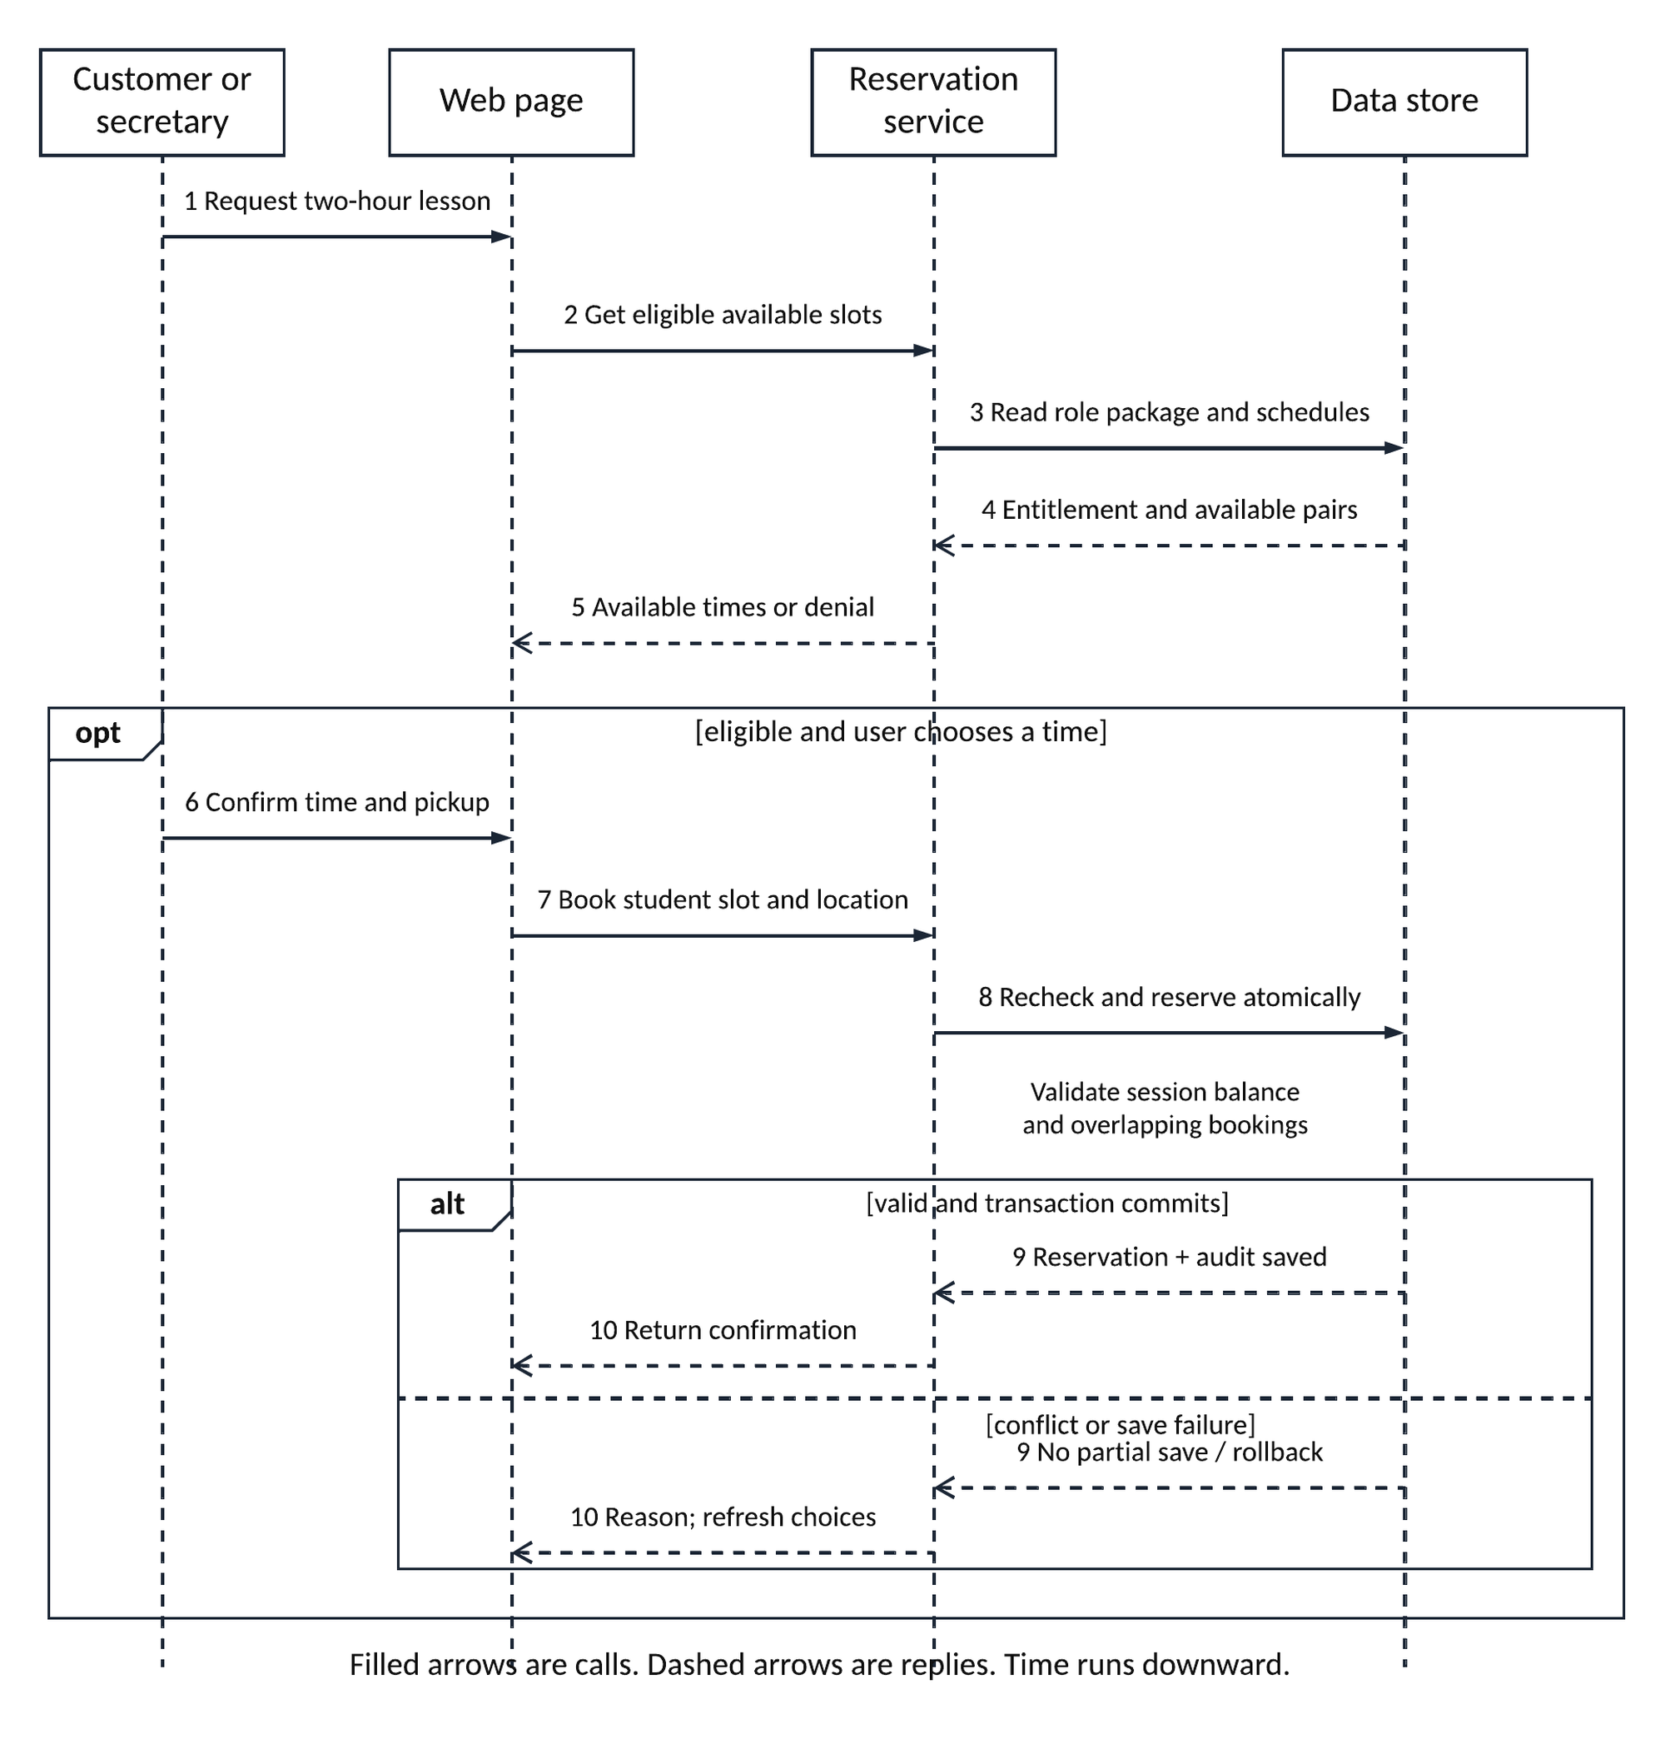
Figure 5. Schedule driving lesson. Lifelines and messages show ordered interactions. The opt frame covers a selected eligible slot; alt separates a committed booking from a conflict or save failure.
The reservation service enforces authorization on the server. The data-store transaction checks the package balance, locks the relevant schedule records, inserts the reservation, and appends the audit event. Confirmation follows commit. Rollback preserves the previous schedule and allowance. The web page then displays either confirmation or refreshed choices.

UML Class Diagram
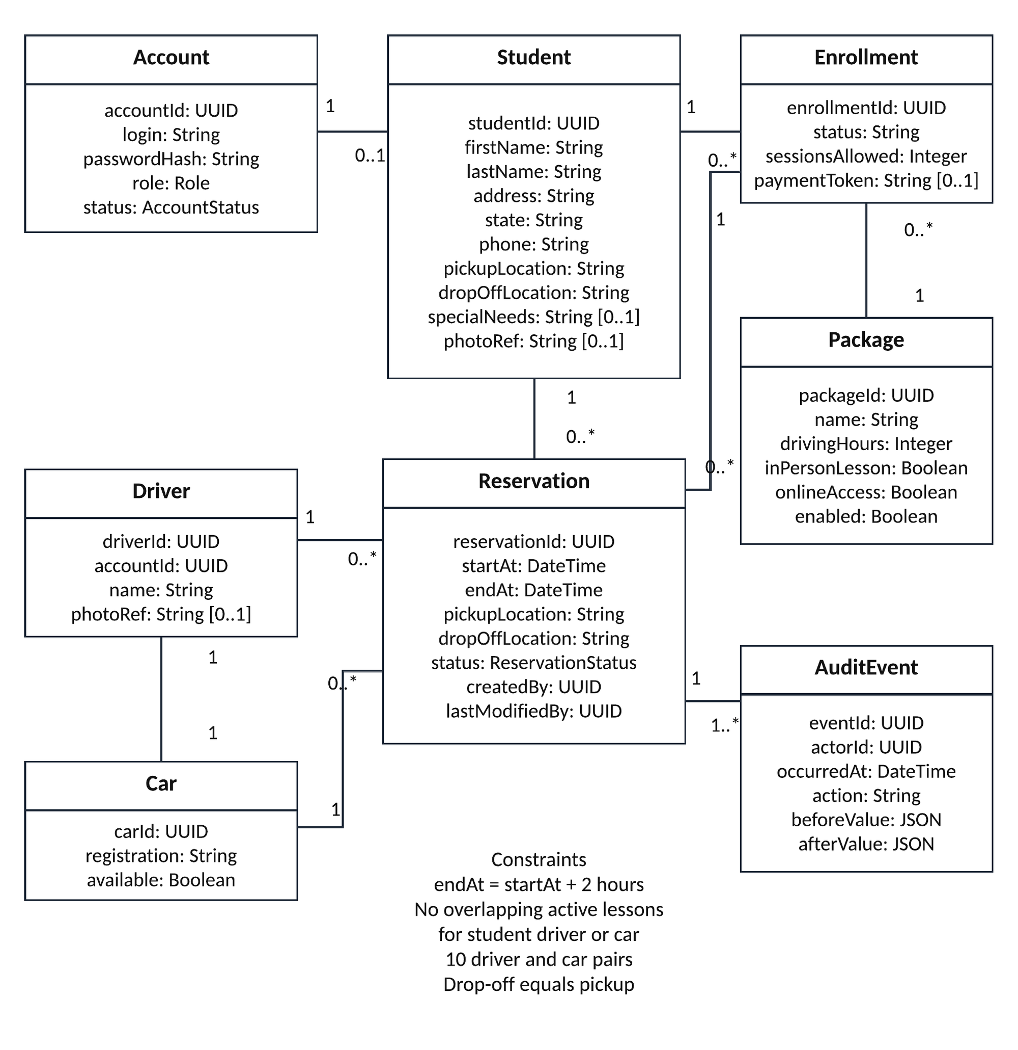
Figure 6. Reservation and account class view. Attribute types appear after colons. Multiplicities identify how many instances participate in each association.
A student has one account; a staff account has no student profile. Each enrollment belongs to one student and one package. Each reservation belongs to one enrollment and student, with one driver and one car. AuditEvent records every reservation creation, change, and cancellation. A driver/car pair is one-to-one for the initial fleet; assignment history is retained by each reservation.

UML Class Diagram continued
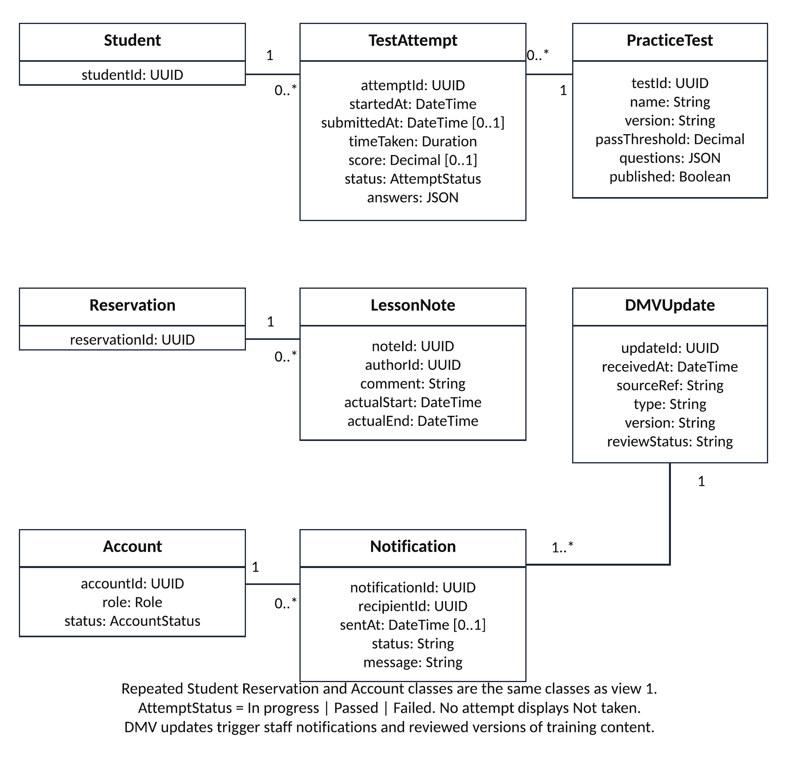
Figure 7. Learning and notification class view. Shared class names refer to Figure 6. Optional attributes use multiplicity [0..1]. Methods are intentionally omitted.
Each attempt references one version of a practice test. Lesson notes reference their reservation and author account. A DMV update generates one or more staff notifications. Account references in createdBy, lastModifiedBy, actorId, authorId, and recipientId are foreign keys to Account. Course content is stored as versioned files with metadata; the diagrams focus on the principal operational classes.

Technical Requirements

Hardware and client access
Customers and staff need a computer, tablet, or smartphone with a supported modern browser and internet connection. Office staff need a workstation, reliable router, and printer for activity reports. Drivers need a device to view assigned lessons and enter notes. DriverPass does not need an on-site application or database server. Cars are scheduled business resources, not computing hosts.
The hosting provider supplies compute, storage, networking, and backup capacity. Size the initial environment for the ten driver/car pairs and expected customer traffic, then adjust using measured demand. Ten cars do not determine the number of concurrent website users. Peak user count and minimum device specifications must be confirmed before sizing and procurement.

Software and application structure
Use a responsive browser interface, a server-side application service, a relational database, and protected object storage for online course materials, optional profile photos, and generated reports. The application exposes registration, package selection, booking, learning, reporting, and administration functions. A centralized authorization layer checks the actor and target record on every request. Separate modules keep future changes maintainable without promising self-service module changes in this release.
The relational database enforces unique identifiers and relationships. Store lesson times with a time-zone-aware representation and show the agreed business time zone in the interface. Validate a two-hour duration and equal pickup/drop-off locations. One transaction rechecks package allowance and prevents overlapping active reservations for each student, driver, and car. Use an idempotency key to prevent a retried submission from creating a duplicate booking.

Development and design tools
The CASE tool is Lucidchart. The revised model was imported, visually verified, and exported from Lucidchart for these deliverables. Development also needs version control, an integrated development environment, database migration tools, automated build/test tooling, and a separate test environment. These are proposed tool categories, not products selected by the client.

Interfaces and customer records
Provide clear forms for first and last name, address, state, phone, pickup/drop-off location, package, and payment entry. Include optional special-needs information and student/driver photo references carried forward from Project One’s interpretation of the client sketch. Limit access to sensitive profile information. The customer page shows test name, elapsed time, score, status, lesson times, and driver comments. Include a DriverPass contact page and authorized staff contact functions.

Technical Requirements continued

Cloud infrastructure and recovery
Use managed application hosting and a managed database behind encrypted web connections. Keep the database off the public internet, store secrets in a managed secret store, and separate development, test, and production environments. Use monitoring for failures, capacity, backup completion, and unavailable external services. The provider manages underlying infrastructure; Ian remains responsible for permissions, configuration, incident response, and recovery review.
Proposed operating targets, subject to client approval: 99.9% monthly availability; routine page responses within three seconds under an agreed test load; nightly encrypted backups retained for 30 days; point-in-time recovery with no more than 15 minutes of data loss; and service restoration within four hours. Use redundant hosting, backup isolation, and scheduled restore exercises to support those targets. These values are design proposals, not commitments in the interview.

Security and account recovery
Require unique accounts, protected password hashes, encrypted transmission and storage, session expiration, and server-side access checks. Proposed additional protections include multifactor authentication for staff and throttling of repeated failed sign-ins with temporary lockout and IT alerts. Exact thresholds require agreement. Blocked accounts lose active sessions and cannot regain access through password recovery.
Provide a self-service reset using a verified contact channel and an expiring single-use token. The verified recovery address or channel is an additional registration detail to confirm with DriverPass because the interview lists phone information but does not prescribe a recovery mechanism. Ian can initiate resets and block accounts without seeing users’ passwords. Record administrative changes in the audit log.
Role | Permitted work
Customer | Own profile, enrollment, appointments, eligible learning, and progress
Secretary | Student registration, contact details, and customer bookings
Driving instructor | Assigned lessons, necessary pickup details, and lesson notes
Owner | Business reports, activity review, exports, and package disabling
IT officer | Account management, resets, access blocking, and system operations
Proposed payment design: collect card number, expiration date, and security code through the payment provider’s protected entry flow. Store a payment reference/token and outcome in DriverPass, not the card security code or full card number. Limit exported information to the owner’s business need and exclude payment credentials and password data. The provider and detailed payment workflow require selection before development.

Technical Requirements continued

Reservation and package rules
Populate the three package definitions exactly as shown on page 1. An enrollment snapshots its purchased session allowance. Derive available sessions from that allowance minus completed and currently reserved sessions; modifying an existing booking does not consume another session. Cancelling changes its status and preserves its history. Releasing an unused session after cancellation is a proposed policy; cancellation deadlines, fees, refunds, no-shows, and expiration rules remain client decisions.
Maintain ten available driver/car pairs initially. Every confirmed lesson identifies one pair and one customer. Do not permit overlapping reservations, including bookings entered by the secretary. Modification repeats the booking checks and atomically replaces the old slot only when the new one is valid. Cancellation releases the slot and appends an audit event in the same transaction. Preserve actor, timestamp, action, before/after values, original creator, and last modifier. Print activity reports filtered by date, actor, and reservation.

Learning and DMV updates
The server checks Package Three entitlement before returning online classes or tests. Persist started/submitted times, score, status, answers, and the test version. Display Not taken for tests without an attempt. Keep in-progress attempts tied to their original published version so an update does not change the grading rules mid-test. Staff review updates before publishing new class material or questions.
A DMV integration adapter receives or retrieves rules, policies, and sample questions through an agreed feed. Record source, version, and receipt time, deduplicate repeated updates, and notify the owner and appropriate staff when new information arrives. Monitor failed retrievals and retry without replacing working content with an incomplete update. The interview does not establish that a DMV API exists; the feed, permissions, update frequency, and review owner must be confirmed. A supported manual receipt process may be needed until an integration is available.

Reports and offline access
Provide printable activity reports and downloadable reports in CSV or XLSX format for Excel. Filter by authorized scope and log exports. Reports may include reservations, driver assignments, test progress, and lesson notes. A downloaded file is a point-in-time copy for offline analysis. Editing that file never updates the live database, and this release has no offline data entry or import-based synchronization.

Technical Requirements verification
The following checks translate the interview and Project One requirements into acceptance evidence. They are planned implementation tests; no DriverPass application has been built or tested as part of this design assignment.
Requirement | Acceptance evidence
Package differences | One allows 3, Two 4, and Three 6 driving lessons. Only Three opens online content and tests. Two and Three include the in-person lesson.
Scheduling | Customer and secretary book the same two-hour schedule. Simultaneous attempts for one driver/car pair produce one confirmed booking.
Changes and auditing | A failed move preserves the old slot. Modification and cancellation record actor, time, and before/after values in a printable report.
Test progress | An unstarted test shows Not taken. Start shows In progress. Submission stores score, time taken, version, and Passed or Failed.
Roles and reset | Cross-customer access fails. Expired or reused reset links fail. Ian can block accounts and invalidate sessions.
DMV updates | A new update creates a staff notice. Duplicate or failed deliveries do not overwrite published content.
Cloud and exports | Restore a backup in a test environment. Open an authorized export in Excel. Offline edits do not change live records.
Scope | Disabling stops new package registrations. No screen adds or removes package modules in this release.

Sources
Southern New Hampshire University. (n.d.). CS 255 DriverPass Interview Transcript [Course interview]. DriverPass Interview section, including the package list, reservations, security, progress, and cloud-access requirements.
Hasan-Watson, T. (2026). CS255 Project One Business Requirements [Completed student document]. Reviewed local file: CS255 Project One Business Requirements - Tyieshia Hasan-Watson.docx. Used Requirements, User Interface, Assumptions, and Limitations.
Hasan-Watson, T. (2026). DriverPass System [Module Six use case diagram]. Available source: Disscussion WK6.pdf.
Southern New Hampshire University. (n.d.). CS 255 System Design Document Template and CS 255 Client Presentation Template. Section order and source formatting guided these deliverables. All proposed policies and numerical service targets above need client review.

